CREDIT CARD PROCESSING

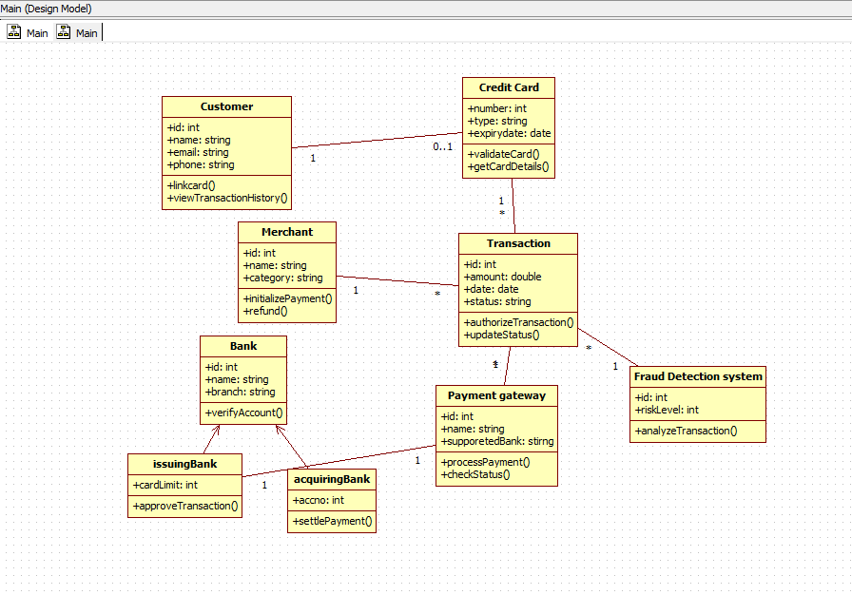

HOTEL MANAGEMENT SYSTEM

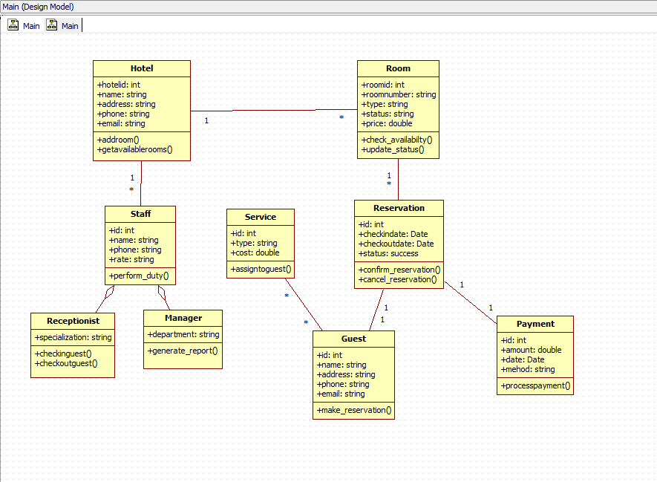

LIBRARY MANAGEMENT SYSTEM

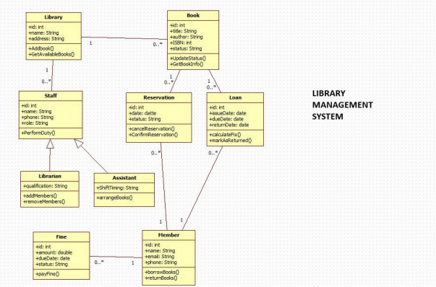

PASSPORT AUTOMATION SYSTEM

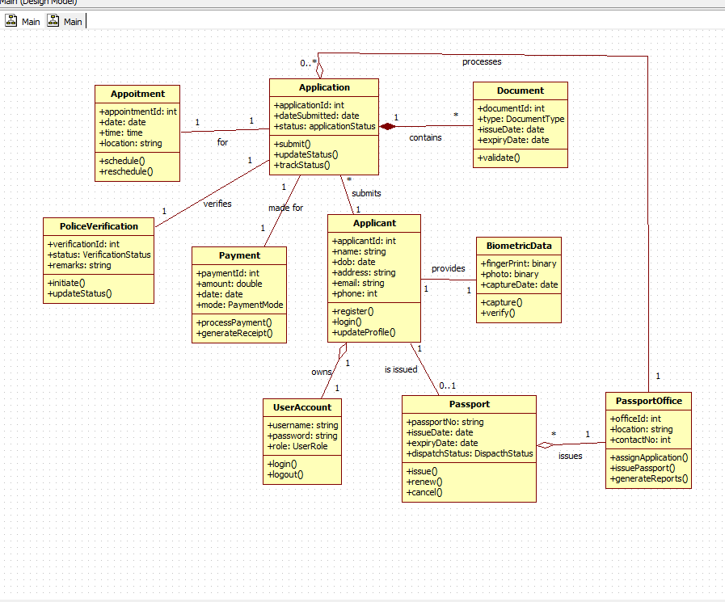

STOCK MAINTAINANCE SYSTEM

